<https://www.drivedigitally.com/hwhavenew/microkey-client-details/11>

why this 11 comes from ?

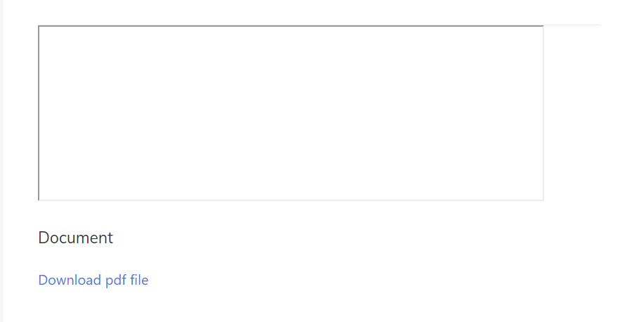

Why this download comes like this way ?.

Download should be works like as per attachment like .pdf, jpeg , xls, so on .

Why this white empty space.?

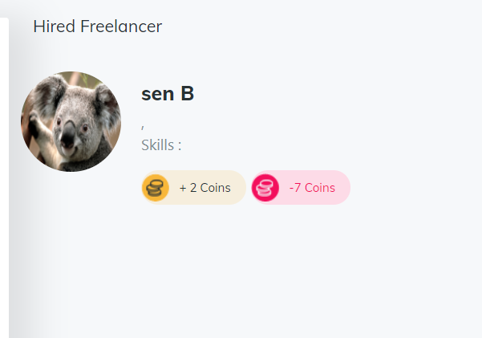

At here for freelancer needs to add location, skill.



What about this white write up , it should not like this,

<https://www.drivedigitally.com/hwhavenew/microkey-list-clientpanel>

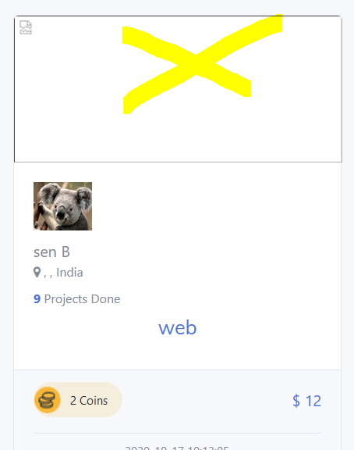

Need to follow this structure.

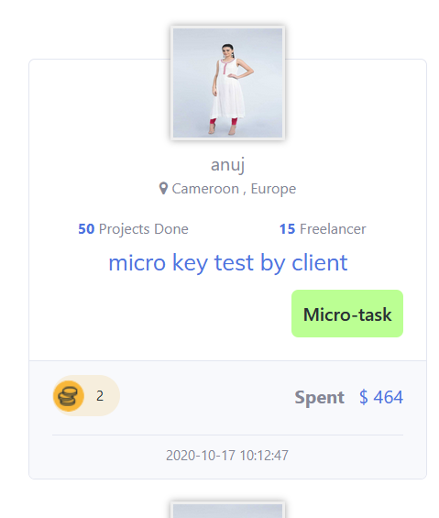

<https://www.drivedigitally.com/hwhavenew/microkey-details/11>

here entire project details will publish , which client posted in micro key . from this area freelancer will post there proposal. This section needs to create.

<https://www.drivedigitally.com/hwhavenew/browse-task>

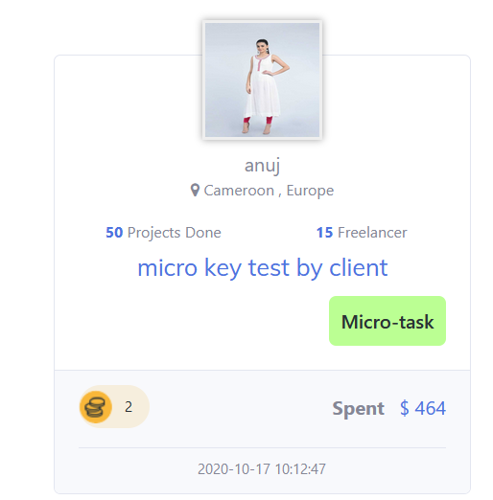

This section will be dynamic , project , freelancer, spend all.

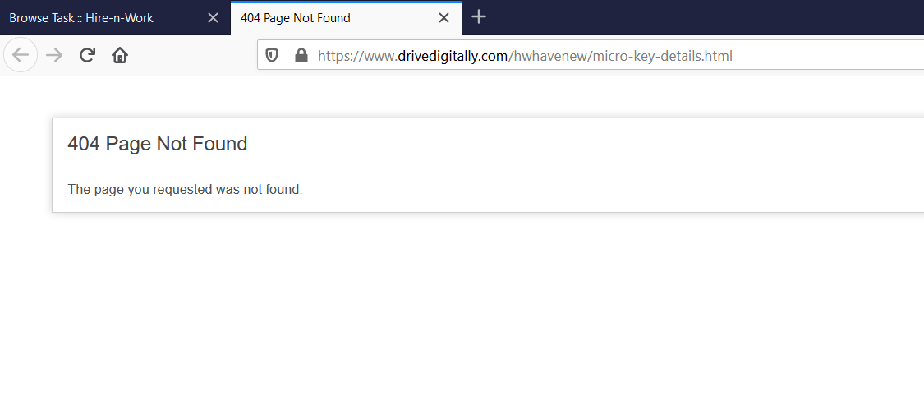

Why this 404, here needs to show what micro key project post by client, also from here keep a option for login & post the proposal.